**HANDWRITTEN TEXT PATTERN RECOGNITION**

*Anurag G Deepak S D C Sagar Patil Harsha J K Prof, Hemalatha M*

*Computer Science Computer Science Computer Science Computer Science Dept of CSE*

*VTU, Belagavi VTU, Belagavi VTU, Belagavi VTU, Belagavi VTU, Belagavi*

*Karnataka, India Karnataka, India Karnataka, India Karnataka, India Karnataka, India*

**ABSTRACT**

***Character recognition from handwritten images is of great interest in the pattern recognition research community for their good application in many areas. To implement the system, it requires two steps, viz., feature extraction followed by character recognition based on any classification algorithm. Convolutional neural network (CNN) is an excellent feature extractor and classifier. It is having multiple applications fields such as robotics, medicine, and security and surveillance. In this article, a CNN is implemented for the NIST dataset with appropriate parameters for training and testing the system. The system provides accuracy up to 94%, which is better with respect to others. It also takes very low amount of time for training the system.***

**Keywords:** *Convolutional Neural Network (CNN), TensorFlow, Python, OpenCV, Flask, Jinja Template, Kerass, Fetch API, CSS Frameworks, Representational State Transfer.*

1. **INTRODUCTION**

Hand-written text pattern recognition is considered as one of the methods to communicate between man and machine. In handwriting recognition (HWR) the device interprets the user's handwritten characters or words into a format that the computer understands. Many methods or models are provided to recognize text with various accuracy. Performance of the system is determined depending on attributes such as the size of the text, the writing style, and the rate of recognition. Web based application is used in our project that uses the text written image to display the results identified.

We used the Convolutional Neural Network Model in our system. We used the publicly available NIST Dataset which contains samples of handwritten characters from thousands of writers. The neural network model which we have used is Convolutional Neural Network. CNN’s are State-of-Art neural networks which have huge applications is ﬁeld of Computer Vision. The neural network model was trained using TensorFlow which is an open source library used for Machine learning applications. OpenCV was used to perform various image processing operations like segmentation, thresholding and Morphological Operations. OpenCV is an open source library which is used for Image processing.

1. **RELATED WORKS**

Immense research is going on in the ﬁeld of handwritten character recognition. Many people have developed systems for handwritten character recognition. We have studied some of the systems Immense research is going on in the ﬁeld of handwritten character recognition. Many people have developed systems for handwritten character recognition. We have studied some of the systems Their system produces near accurate results but sometimes produces errors if the handwritten characters are not properly segmented. One of the Authors has presented a unique method for authenticating a person based on their handwriting. The author has used the Multi-layer feed forward neural network in their system. The author has proposed in this paper that the height and width of a handwritten alphabet is unique for each and every person. The author has presented a method for recognition and identiﬁcation of a person from their handwriting.

1. **VARIOUS TOOLS USED**

To design this handwritten character recognition system, we have used various tools like Python, OpenCV and TensorFlow Flask Server on PORT 5000, Jinja2 Template engine, Keras is used to load Machine Learning Model into the server, Representational State Transfer, Fetch API, CSS Frameworks

1. **IMPLEMENTATION**

The proposed system identifies the text by the image which is selected and uploaded from the local storage. The system recognizes the image and gives the output in a digitalized text format which can be further converted to human speech. The time consumed for training the model has been reduced and accuracy has been increased. Progressive Web App has been implemented for user interaction which reduces the scope of mobile ﬁrst approach. Implementation Tools used :

* Flask Server on PORT 5000
* Jinja2 Template engine
* Keras is used to load Machine Learning Model into the server

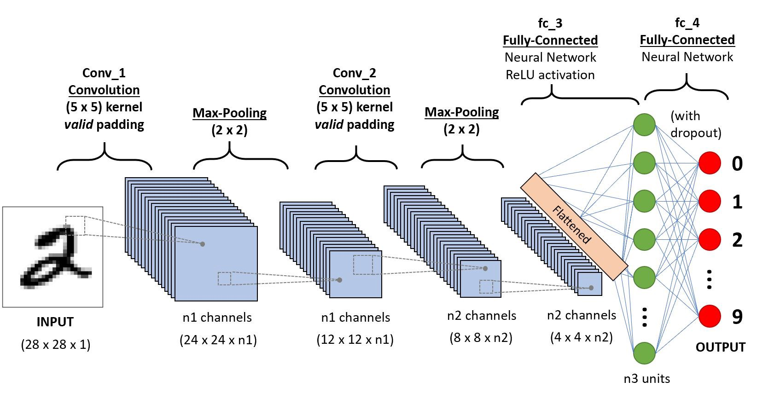

Fig-1: Illustration of the image classification using CNN architecture

Convolutional neural network (CNN) is the current state-of art neural network which has wide applications in fields like Image and Video Recognition, Natural Language Processing, Recommender systems. CNN’s are biologically inspired neural networks. CNN’s are very good at image recognition. In case of CNN the input is a multi-channeled image (Often an image having Red, Green and Blue channels). A CNN comprises of a stack of Convolutional layer and a Max-pooling layer followed by a fully connected layer. The convolutional layer is the most important layer of network. It performs the convolution operation. The pooling layer comes after the convolutional layer. This layer is needed because in case of larger images , the number of trainable parameters can be very large. This increases the time taken to train a neural network and is not practical. The pooling layer is used to reduce the size of image. We used the NIST database which contains thousands of images of handwritten characters. Some of them are shown below. However these images were originally of size 128x128 pixels. The images in the training set were cropped to a size of 28x28. Reducing the size of images decreases the overall time taken to train the neural network model. After the training the Neural network model, an accuracy of up to 94% was obtained

1. **SYSTEM DESIGN**

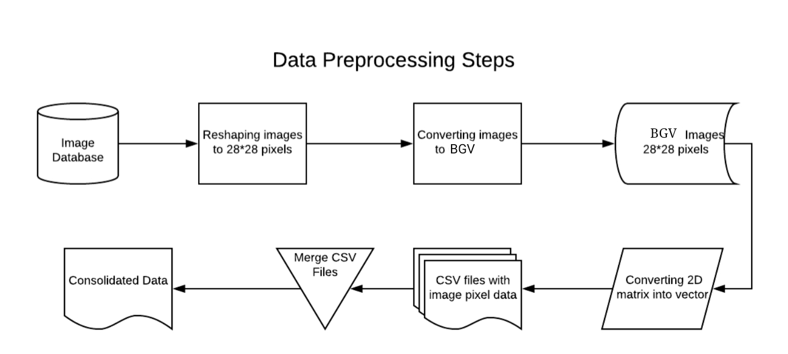

Fig-2

**STEP-1: Convolution step**

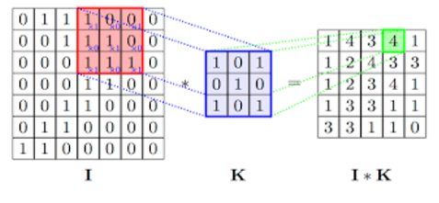

**STEP-2: ReLu(Rectifier Linear Units)**

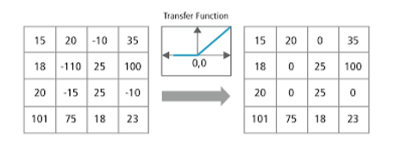

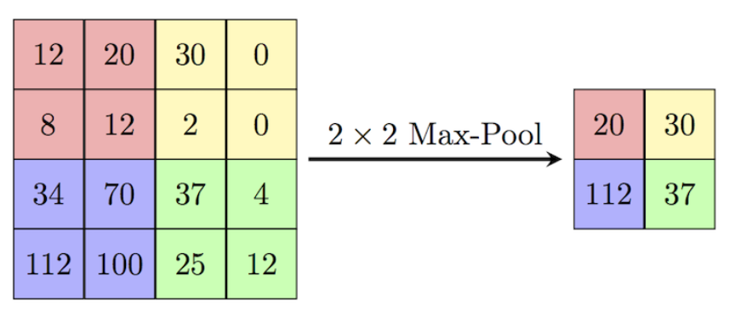**STEP-3: Max pooling**

1. **SOME OF THE IMAGES USED FOR TRAINING NEURAL NETWORK**

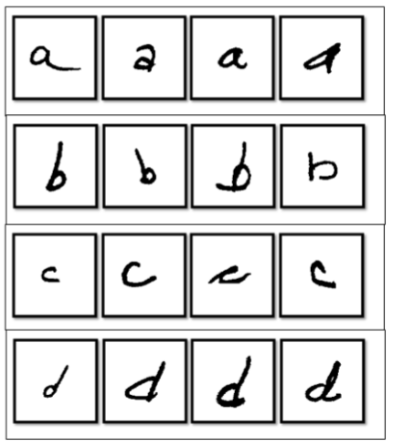

Following steps are involved in processing of images:

1) Pre-processing: This is the ﬁrst step performed in image processing. In this step the noise from the image is removed by using median ﬁltering. Median ﬁltering is one of the most widely used noise reduction technique. This is because in median ﬁltering the edges in image are preserved while the noise is still removed.

2) Conversion to Gray-Scale: After the pre-processing step, the image is converted into grayscale. Conversion into grayscale is necessary because different writers use pens of different colours with varying intensities. Also working on grayscale images reduces the overall complexity of the system.

3) Thresholding: When an image is converted into grayscale, the handwritten text is darker as compared to its background. With the help of thresholding we can separate the darker regions of the image from the lighter regions. Thus because of thresholding we can separate the handwritten text from its background.

4) Image Segmentation: A user can write text in the form of lines. Thus, the thresholder image is ﬁrst segmented into individual lines. Then each individual line is segmented into individual words. Finally, each word is segmented into individual characters. Segmentation of image into lines is carried out using Horizontal projection method. First the thresholder image is inverted so that background becomes foreground and vice-versa. Now the image is scanned from top to bottom. While scanning, the sum of pixels in each row of image is calculated

1. **CONCLUSION AND FUTURE SCOPE**

An online handwriting recognition system for English based characters has been developed. The system is writer-independent text recognizer developed based on convolutional neural network approach with text-to-speech conversion system. There are many developments possible in this system in the future. As of now the system can’t recognize cursive handwritten text. But in future we can add support for recognition of cursive text, Presently the system can only recognize letters. We can add support for recognition of Special symbols in the future. There are many applications of this system possible. Some of the applications are Processing of cheques in Banks, helping hand in Desktop publishing, Recognition of text from business cards, Helping the blind in recognizing handwritten text on letters.

1. **REFERENCES**

* Proceedings of the 2nd International Conference on Inventive Communication and Computational Technologies (ICICCT 2018),  
  IEEE Xplore - Handwritten Character Recognition Using Deep-Learning.
* **International Journal of Management, Technology And Engineering** **Volume 8, Issue VII, JULY/2018 ISSN NO : 2249-7455.**
* **NIST Handprinted Forms and Characters Database obtained by,**
* https://www.kaggle.com/sachinpatel21/az-handwritten-alphabets-in-csv-format
* <https://medium.com/@himanshubeniwal/handwritten-digit-recognition-using-machine-learning-ad30562a9b64>